Alex Arnold
Professor Torres
3-6-25
IT 120-41198
Lab 6

Part A: Netlab1 NDG Ethical HackingLinks to an external site.Links to an external site.
Applications
- OWASP Zap
  - bWAPP
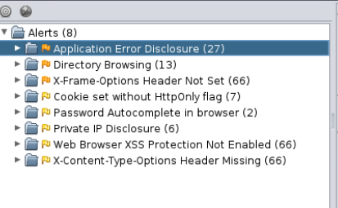
    - What was the most critical vulnerability found by each tool?
      - Medium risk Application error disclosure was at the top
  - Mutillidae
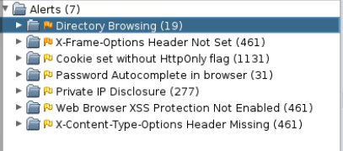
    - What was the most critical vulnerability found by each tool?
      - Medum risk directory browsing is the to alert
  - Damn Vulnerable Web Application
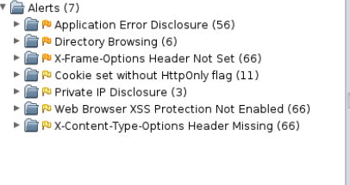
    - What was the most critical vulnerability found by each tool?
      - Application error disclosure was the top of the list
- Nikto
  - bWAPP
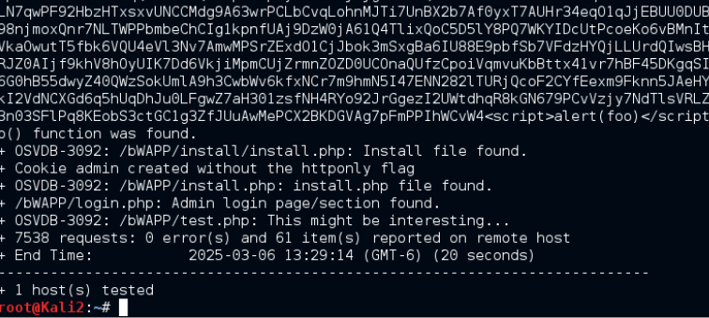
    - What was the most critical vulnerability found by each tool?
      - No priority listings but 61 items were found (install file found)
  - Mutillidae
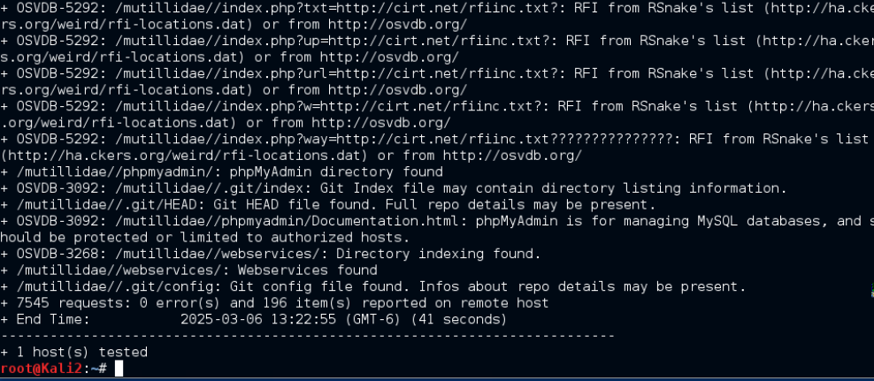
    - What was the most critical vulnerability found by each tool?
does not list specifics but it found 196 issues with the site (directory traversal)
  - Damn Vulnerable Web Application
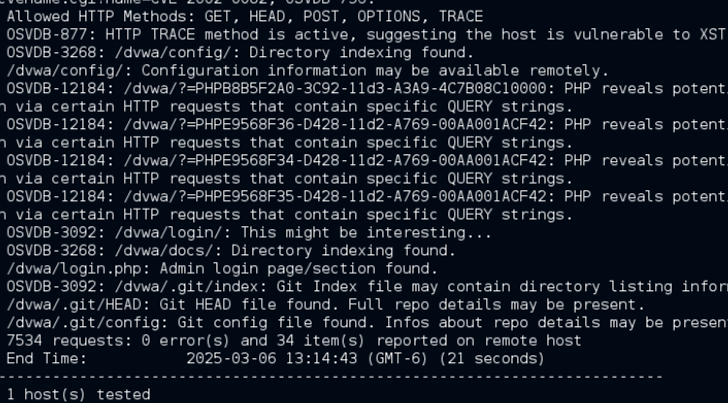
    - What was the most critical vulnerability found by each tool?
      - Nikto does not lost the severoity of the vulnerability but it dis list 34 reported items and a lot of outdated modules.
- Paros Proxy
  - bWAPP
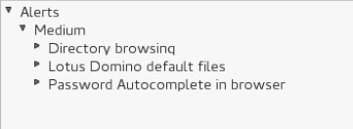
    - What was the most critical vulnerability found by each tool?
      - Most critical was directory browsing
  - Mutillidae
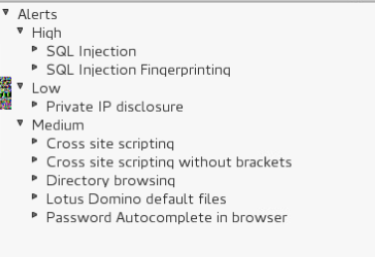
    - What was the most critical vulnerability found by each tool?
      - High vuln with SQL injection as the top
  - Damn Vulnerable Web Application
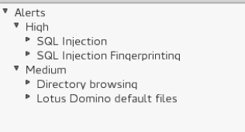
    - What was the most critical vulnerability found by each tool?
      - High with sql injection
- Vega Scanner
  - bWAPP
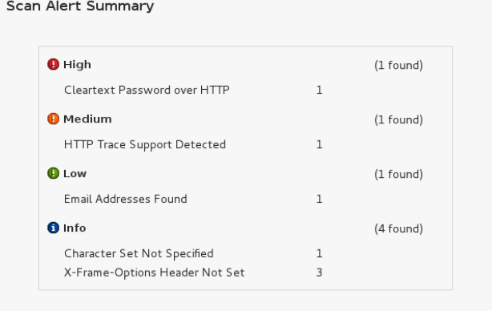
    - What was the most critical vulnerability found by each tool?
cleartext over HTTP
  - Mutillidae
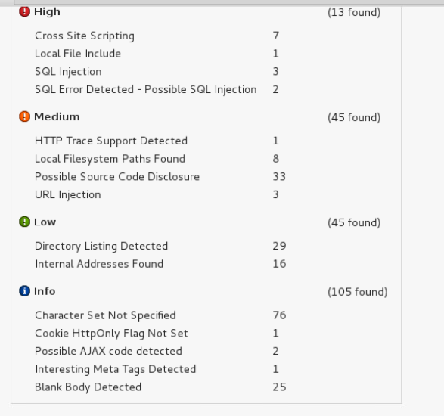
    - What was the most critical vulnerability found by each tool?
      - Cross site scripting
  - Damn Vulnerable Web Application
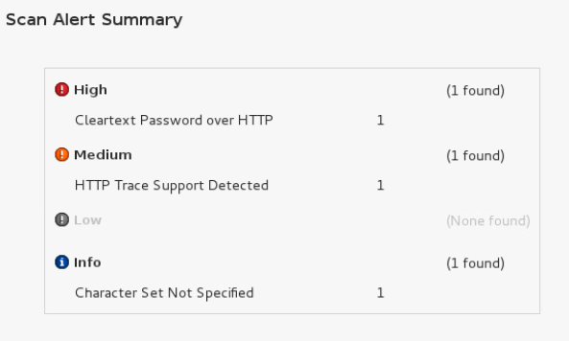
    - What was the most critical vulnerability found by each tool?
    - Clear text passwords over http
- Skipfish
  - bWAPP
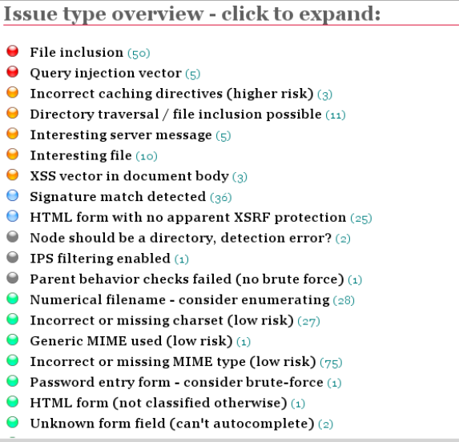
    - What was the most critical vulnerability found by each tool?
      - File inclusion
  - Mutillidae
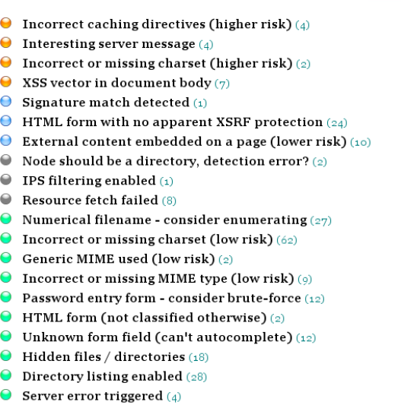
    - What was the most critical vulnerability found by each tool?
      - Incorrect caching directives
  - Damn Vulnerable Web Application
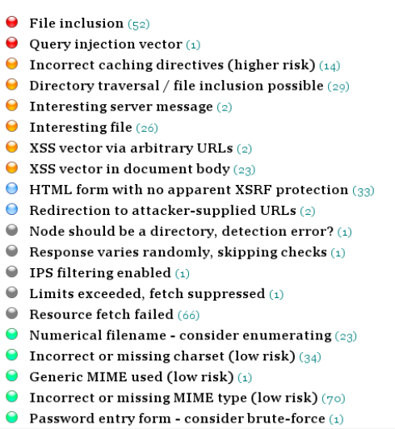
    - What was the most critical vulnerability found by each tool?
      - File injection
After you scan your applications with the above tools:
- What vulnerability was flagged as being severe or critical in one tool and not in another?
  - File inclusion was flagged with skipfish but was not in others,
- Which tool gave you the best results
  - Skipfish but it takes forever to run in comparison to the other tools
- Attempt to locate every website that requires authentication using the above tools.
- Research and attempt the "default credentials" for the websites found.
- What is the name and version of the web application?
- Wordpress v 2.0
- GetBoo v1.04
- Webgoat tomchat v 6.0.24
- Security shepard v 2.4
- Mutillidae v 2.6.24
- Ghost v 1.0
- Wordpress v 2.0
- Joomla v1.5.15
- Tikiwiki apache 2.0
- webcalendar
- App sensor demo application (given pw with no way to change)
- The bodgeIT store – couldn’t find login
- bWAPP
- Authenticator methods lab / swingset interactive v 1.0.1
- Bricks login activity page v 2.2
- The BodgeIt Store
- Gruyere: Login (html 4.01) (user zap)
- WakoPicko
- Rails goat
- Orangehrm (php: 2.4.2)
  - Are there any public vulnerabilities for the web application?

Part B: NDG Security+V3
- Analyze the NDG Security+V3 network
  - Fix the firewalls. All ports should be closed
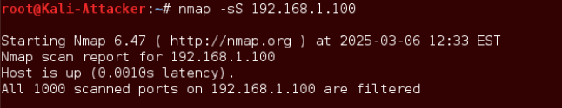
    - Win 16 all ports blocked and firewall active
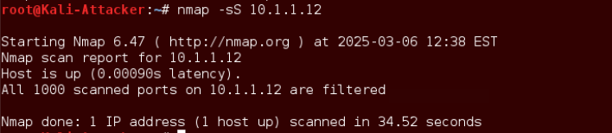
    - Win12R2 all ports blocked and firewall active
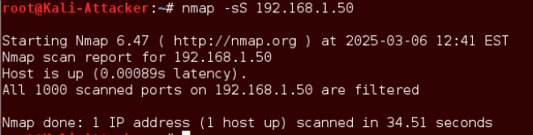
    - Ubuntu all ports blocked and firewall active
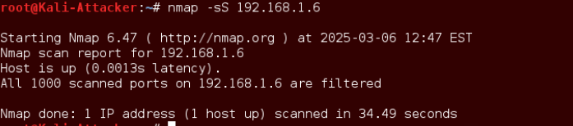
    - Seconion all ports blocked and firewall active
  - Fix the DMZ. DMZ should be accessed by the public IP and should be the only port open. Within the DVL box, activate the HTTP web server. This web server should be accessible on the Kali box.
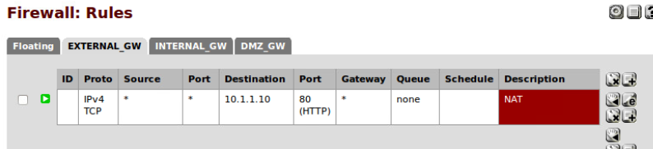
    - Firewall rules fixed and only accessible through the firewall external ip using port forwarding
  - On the DVL network find every website requiring authentication (if any exist)
    - Change the default credentials
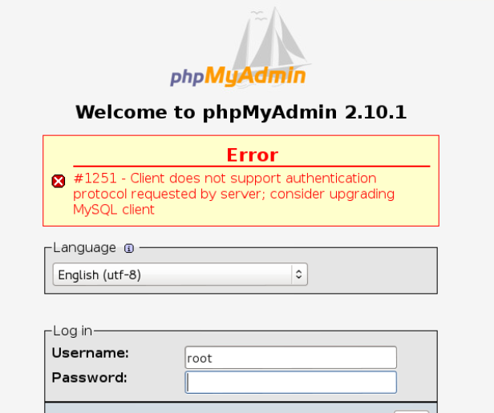
    - Changed password and it broke
    - That was the only login I could find for the site

Part C: NDG Ethical Hacking
- Analyze the NDG Ethical Hacking network
  - Fix the firewalls. All ports should be closed
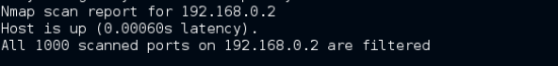
    - openSUSE firewall enabled
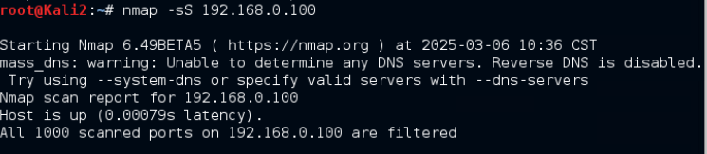
    - all ports closed on security onion
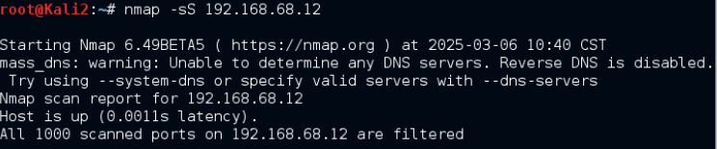
    - all ports on broken web app closed
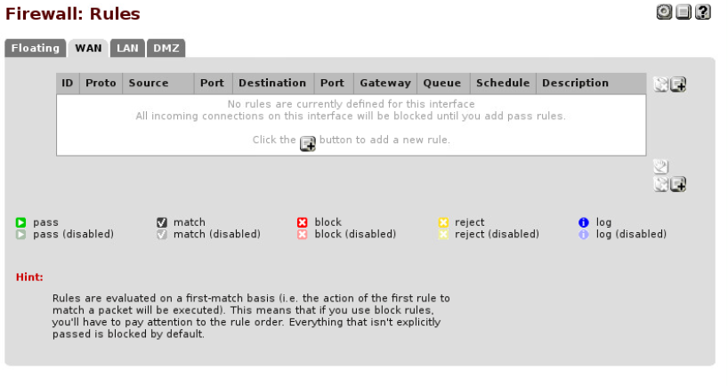
    - pfsense all outgoing traffic is blocked and ports are locked down
  - Fix the IP addresses (public/private)
  - 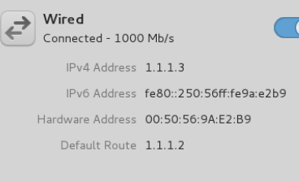
    - Kali ip changed to 1.1.1.3
  - 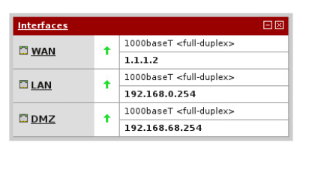
    - The pf sense wan networ has been changed to 1.1.1.2 (1.1.1.1 did not work)

  - Fix the DMZ. DMZ should be accessed by the public IP and should be the only port open
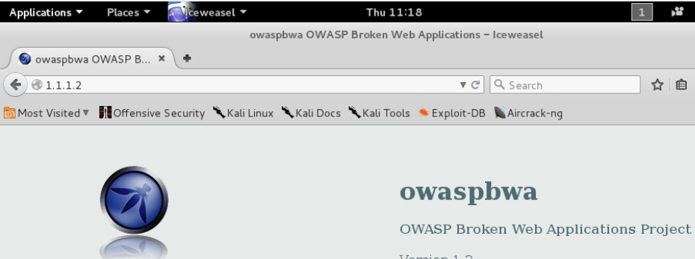
    - Dmz accessible through the firewall port 80

